# LAYING THE FOUNDATION FOR YOUR MARKETPLACE JOURNEY

## MUSKAN BATOOL

## DAY-1 TASK

STEP-01

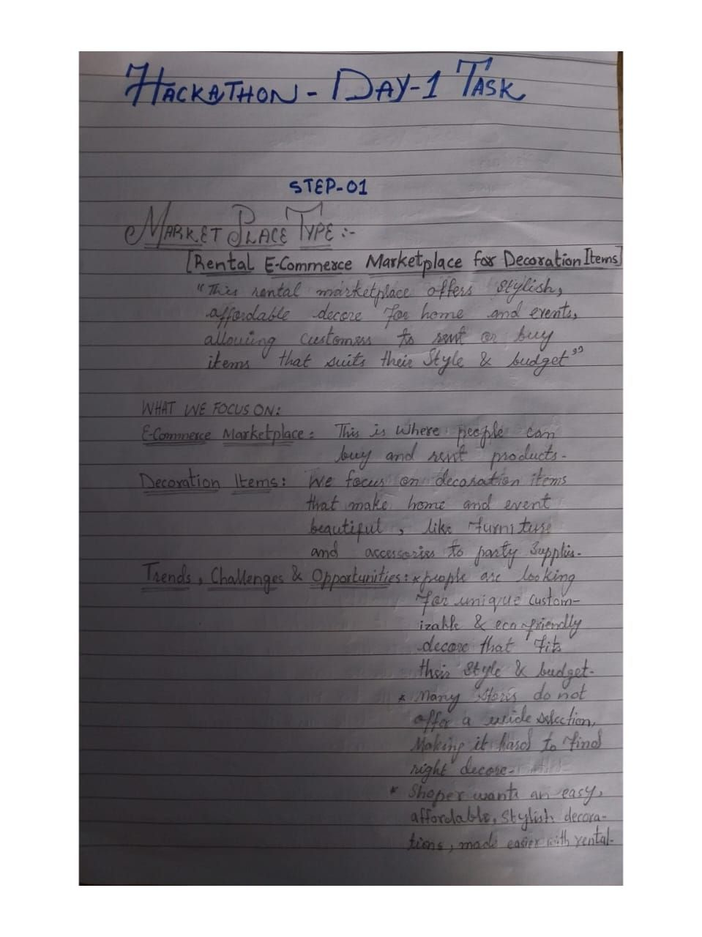

STEP-02

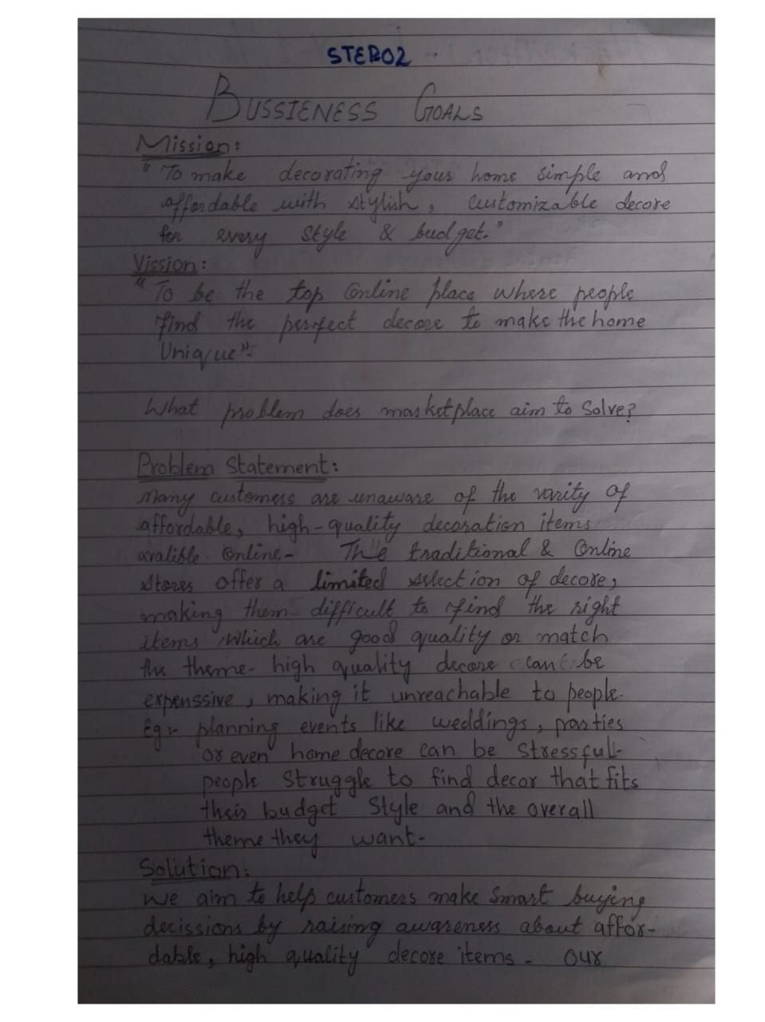

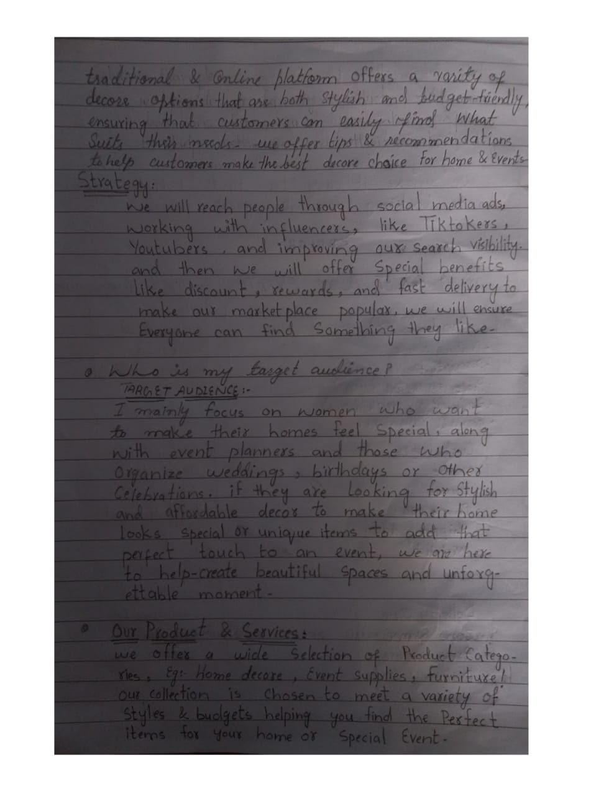

STEP-03

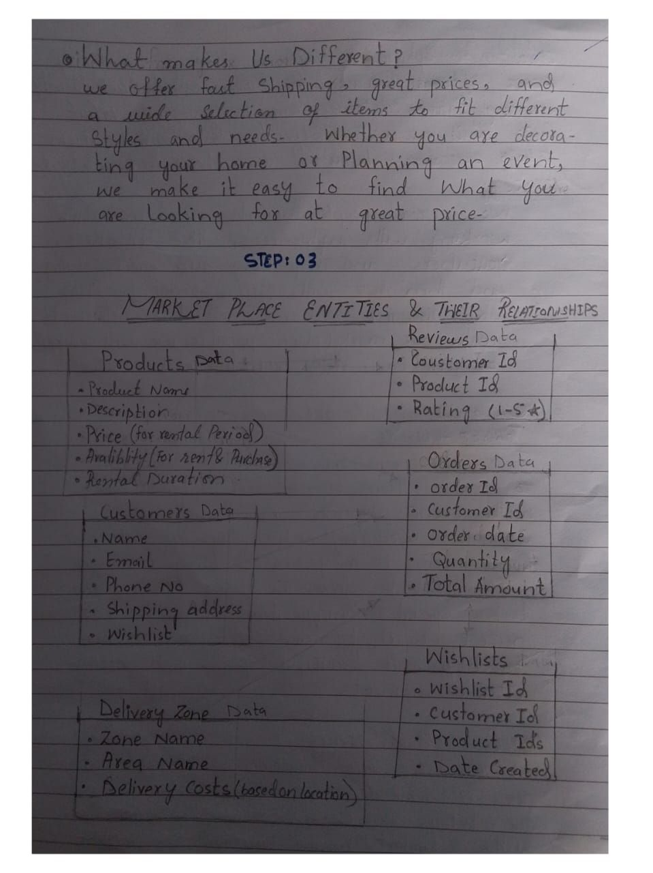

SCHEMA DIAGRAM

